**ME393- ENGINNERING SOFTWARE LAB**

TUTORIAL REPORT: VOF Model



**Instructor: Dr. Ashwani Assam**

**SUBMITTED BY:**

Name: Adarsh Raj

Roll:2201me78

**DEPARTMENT OF MECHANICAL ENGINEERING**

**INDIAN INSTITUTE OF TECHNOLOGY, PATNA**

1. **INTRODUCTION**
2. Examines the flow of ink as it is ejected from the nozzle of a printhead in an inkjet printer Using Ansys Fluent's volume of fluid (VOF) multiphase modelling capability, you will be able to predict the shape and motion of the resulting droplets in an air chamber.
3. **PROBLEM STATEMENT**

The problem considers the transient tracking of a liquid-gas interface in the geometry shown in Figure. The axial symmetry of the problem enables a 2D geometry to be used. The computation mesh consists of 24,600 cells. The domain consists of two regions: an ink chamber and an air chamber. The dimensions are summarized in Table.

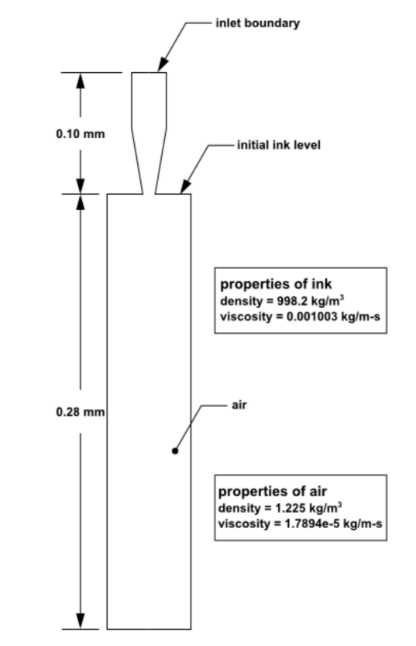

1. **MANIPULAT THE MESH**

This is the default display of the mesh after we read the mesh file *inkjet.msh*

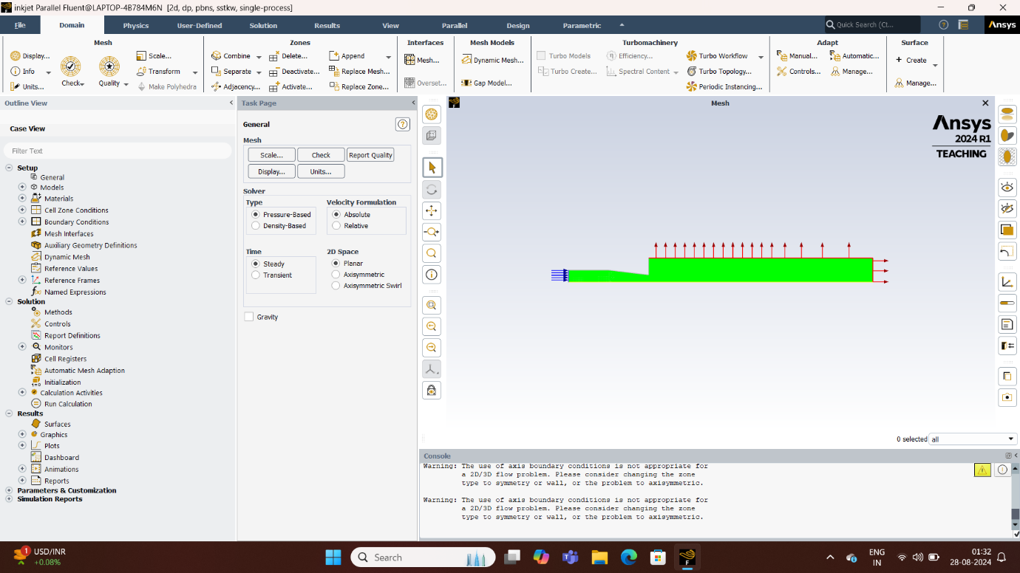

**3.1** Set the graphic display option and camera parameters. After which, the mesh will be mirrored and positioned upright.

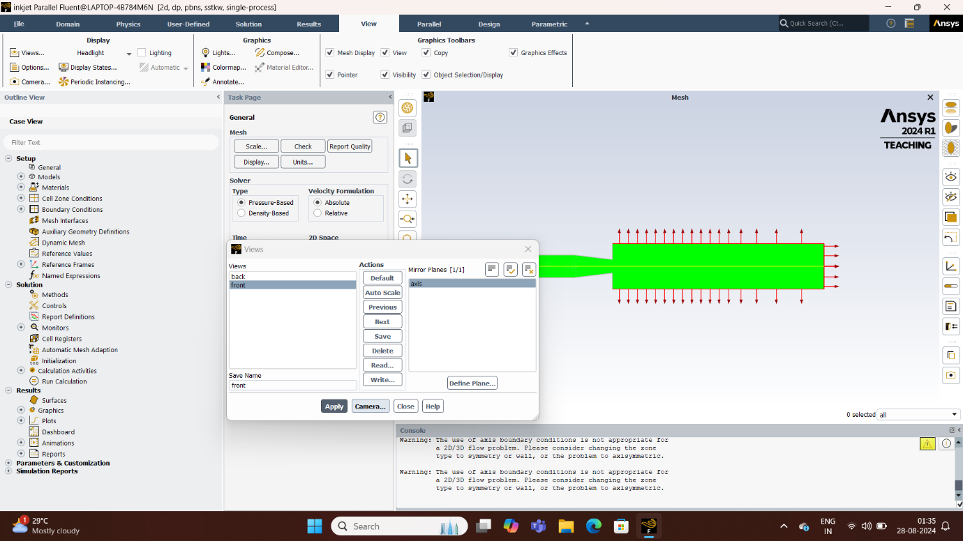

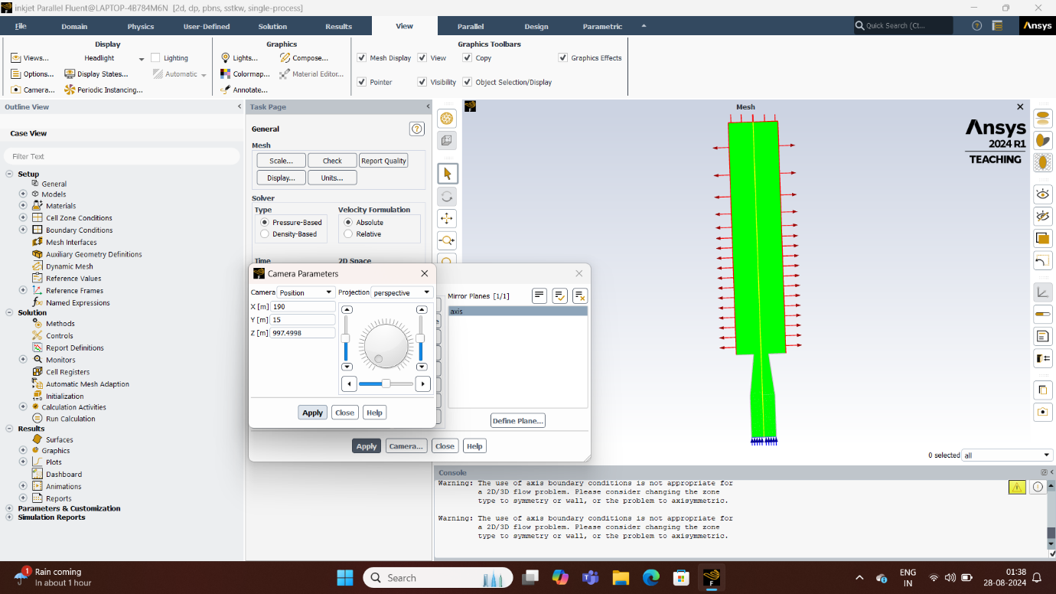

1. **GENERAL SETTING**

**4.1** Perform the mesh check and then scale it. Set the units of length(mm) and surface tension (dyne/cm).

**4.2** Select the Pressure based solver on the Solver group and Transient in Time.

1. **MODELS, MATERIALS, AND PHASES**

**5.1** Enable the Laminar Viscous model and Volume of Fluid multiphase model.

**5.2** Define the Fluent Fluid Material to water-liquid.

**5.3** Specify air in the primary phase and water-liquid in the secondary phase.

**5.4** Enable Wall Adhesion.

**5.5** Set Surface Tension coefficient to constant and value to 75.5 dyne/cm.

1. **OPERATING AND BOUNDARY CONDITIONS**

**6.1** Set the Operating Pressure (Pa) and Reference Pressure location.

**6.2** Set the inlet Boundary Condition for the mixture phase (Velocity Magnitude expression) and water-liquid phase (Volume fraction as 1).

**6.3** Set the outlet Boundary Condition for the water-liquid phase

**6.4** Set the condition for the top wall of the air chamber *wall_no_wet*

**6.5** Set the condition for the side walls of the ink chamber *wall_wet*

1. **SOLUTION**

**7.1** Set the solution method.

**7.2** Enable the plotting of residuals during the calculation.

**7.3** Initialize the solution after the default initial values (Standard Initialization).

**7.4** Define a register for ink chamber region

**7.6** Request the saving of data files every 200 steps.

**7.7** Save the initial case file and run the calculation

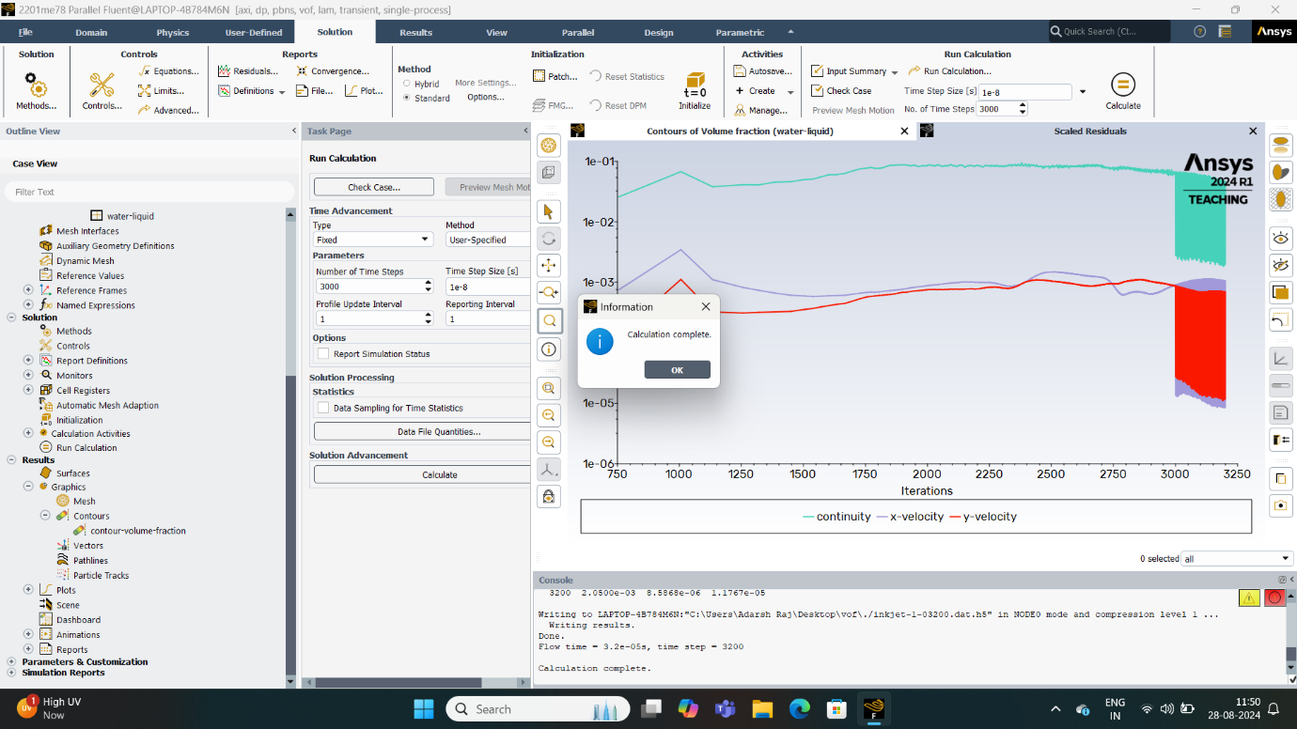

1. **POST-PROCESSING**

**8.1** Read the data file for the solution.

**8.2** Create and display a filled contour of water volume fraction (Phase – water liquid) and save the file.

**8.3** Read the data again for different timestamps but by reloading the contour saved in the previous step.

1. **RESULT AND DISCUSSION**

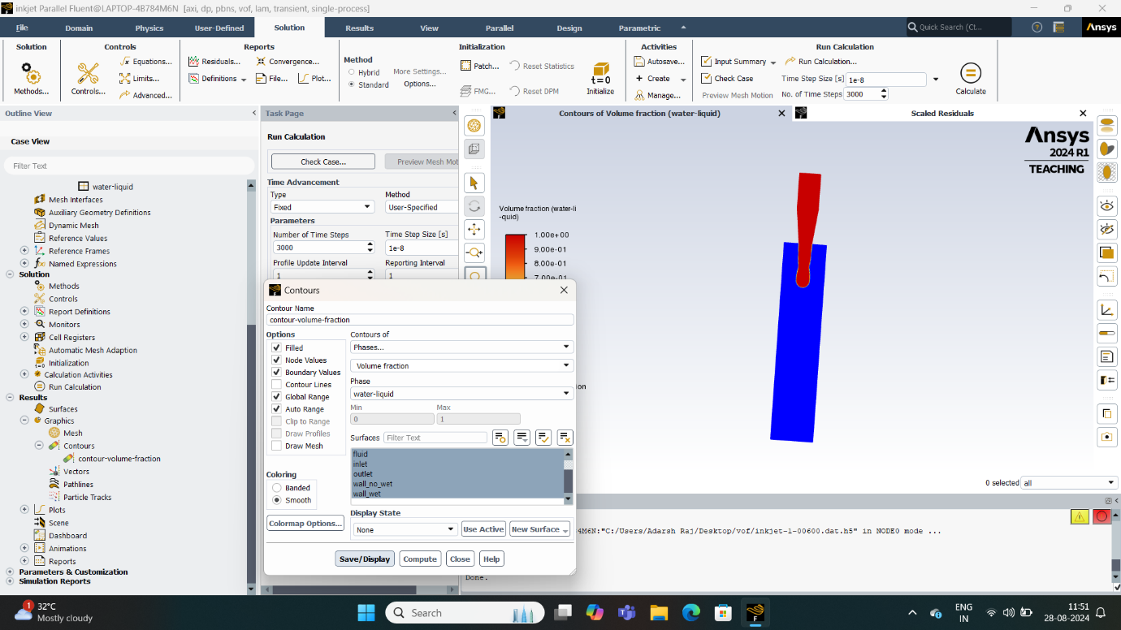

Fig: Contours of Water Volume Fraction After 6 μs

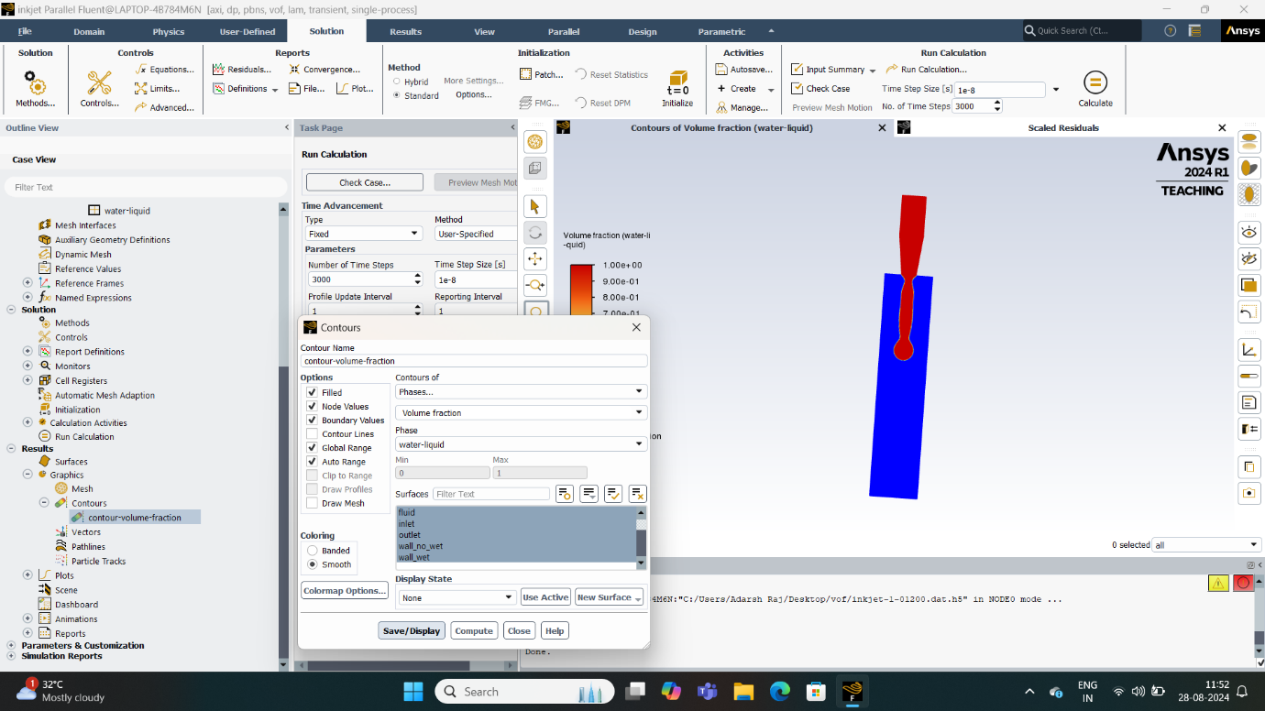

Fig: Contours of Water Volume Fraction After 12 μs

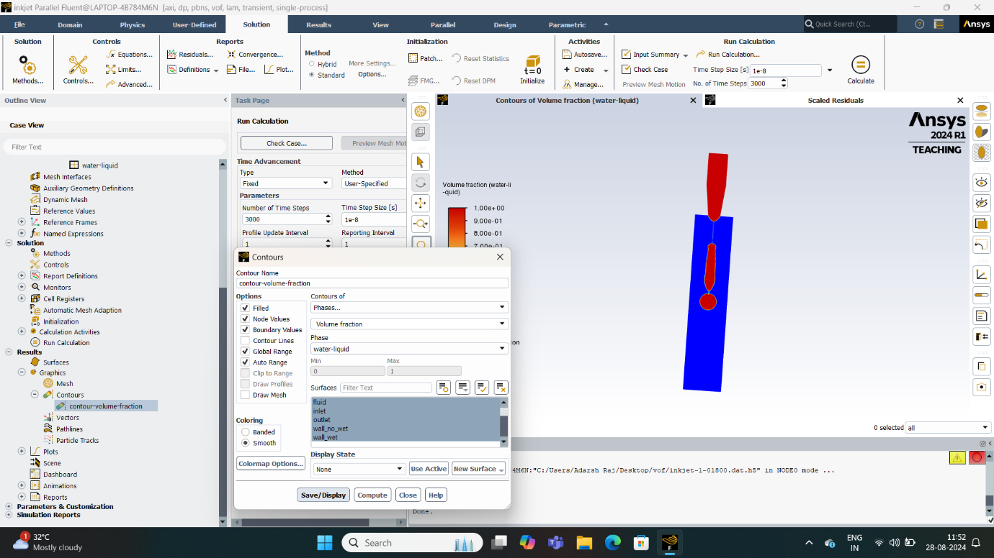

Fig: Contours of Water Volume Fraction After 18 μs

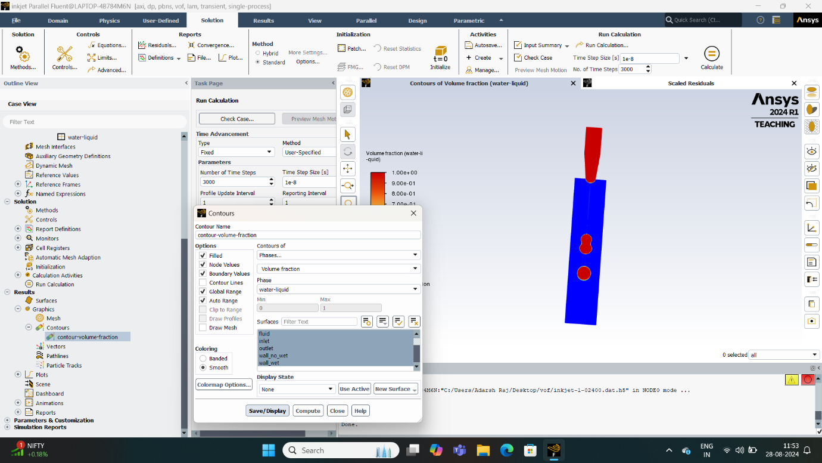Fig: Contours of Water Volume Fraction After 24 μs

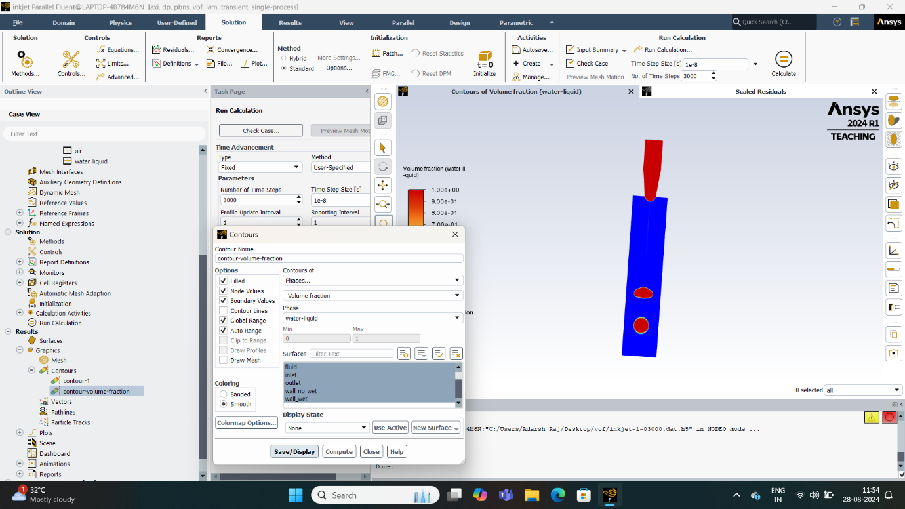

Fig: Contours of Water Volume Fraction After 30 μs